Grade 7 Accelerated · Unit 3 · Lesson 8  Writing Large Numbers in Scientific Notation  Question Bank - Additional 3.08 ANSWER KEY | Name  Date  Period

Show your work. Circle your final answer.
For questions 1 through 4, write each number in scientific notation.
1. 70,000


2. 2,800,000


3. 640,000,000


4. 5,030,000,000


For questions 5 and 6, write each number in standard form.
5. 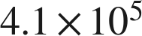
410,000

6. 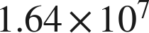
16,400,000

Real quantities.
7. Write each quantity in scientific notation.
a. Earth's beaches hold about 7,500,000,000,000,000,000 grains of sand.
 grains
b. A distance of about 39,900,000,000,000 km.
 km
c. A computer displays a population as 1.2E7. Write it in standard form.
12,000,000

8. Complete each comparison.
a. How many times larger is 8.2 than 4.1?
2
b. How many times larger is  than 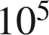?
100
c. How many times larger is 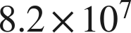 than ?
2 × 100 = 200 times larger

9. Answer each question.
a. About 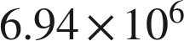 people visited one theme park in a year, and about 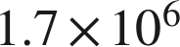 visited another. About how many times larger is the first number? Round to the nearest whole number.
about 4 times
6.94 ÷ 1.7 ≈ 4.08; the powers are equal.
b. China's population is about 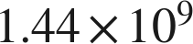 and Mexico's is about 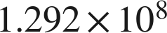. About how many times larger is China's? Round to the nearest tenth.
about 11.1 times
1.44 ÷ 1.292 ≈ 1.115 and 10⁹ ÷ 10⁸ = 10.

10. Which of the following is greater? Explain how you know.
a. 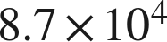 or 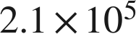
 — 10⁵ is greater than 10⁴; 210,000 > 87,000.
b. 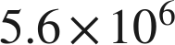 or 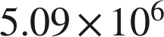
 — same power; 5.6 > 5.09.

11. Which is 71,000,000 written in scientific notation?
● A. 
○ B. 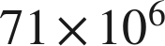
○ C. 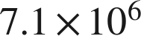
○ D. 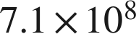
A

12. Select ALL of the expressions that are equal in value to 6,200,000.
☒ A. 
☒ B. 
☒ C. 
☒ D. 
☐ E. 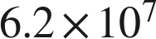
☐ F. 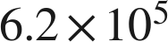
A, B, C and D
Only A is in scientific notation.

13. In question 12, only one of the four equal expressions is written in scientific notation. Which one is it, and why are the other three not?
. The coefficient must be at least 1 and less than 10; 62, 620 and 0.62 are not.

